AARON LOEB

Digital Marketer

PROFILE

EXPERIENCES

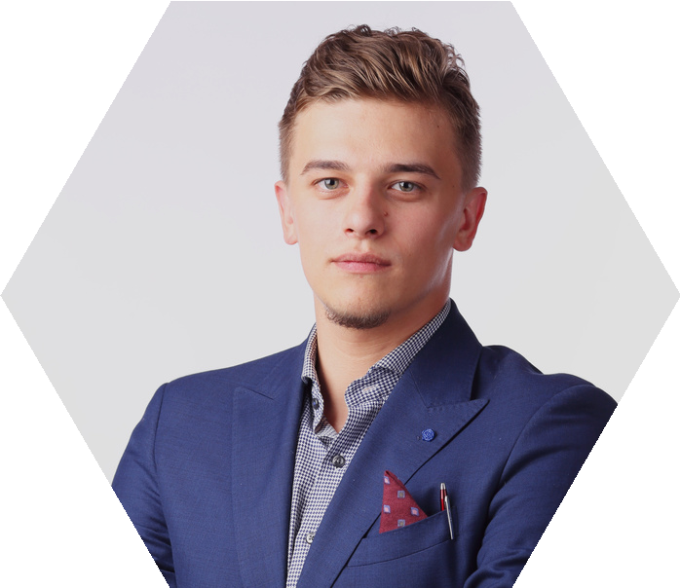Content-creating enthusiast and with 11 months experience in social media organic and KOL marketing (paid channel). I am also a fast- learner, pro-active, and adaptive to changes person who excels in creative, critical, and analytical thinking skills.

CONTACT

+123-456-7890
hello@reallygreatsite.com

SKILLS
Paid Ads Expert
SEO Intermediate

Performance Digital Marketing Project Arowwai Industries | May 2021 - present
My responsibilities include:
- Optimizing search engine (search & shopping) & marketplace Ads. Includes designing campaigns, keyword research, copywriting, bidding optimizations & performance optimization based on previous & relevant data.
- Improved optimization score by 30% and achieved better results with 25% less spent on the previous period.

EDUCATION

International University (2016-2020) Bachelor of Business | Business Faculty GPA of 4.00

